

Intelligent Care System

**Leader_18309002 PARK HOIJAI**

17309001 ANTONY

17309002 KIM TAESIK

18309003 ROH SUNGHO

18309004 SAM LINDAMAN

18309007 LEE EUNSOO

18309008 NABIL MADIH

# Purpose of project

The project aims to perform an intelligent healthcare system that captures and stores images/videos of target individuals, recognizes the identity of the target, and analyzes emotions and behaviors through captured information.

# 1. System analysis

System analysis is the first step for the construction of an effective system. In this chapter, we will thoroughly analyze the demands of the stakeholders to define the system’s goals, boundaries, and requirements for both functional and nonfunctional parts of the system. This analysis will also help identify the potential territories of improvement for the system

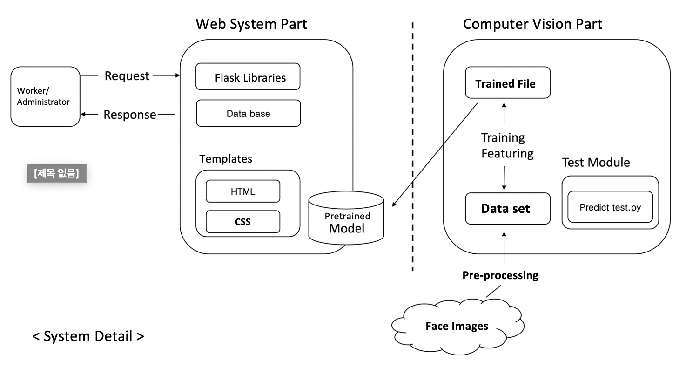

## < System configuration>

## 1.1 Business and user requirements analysis

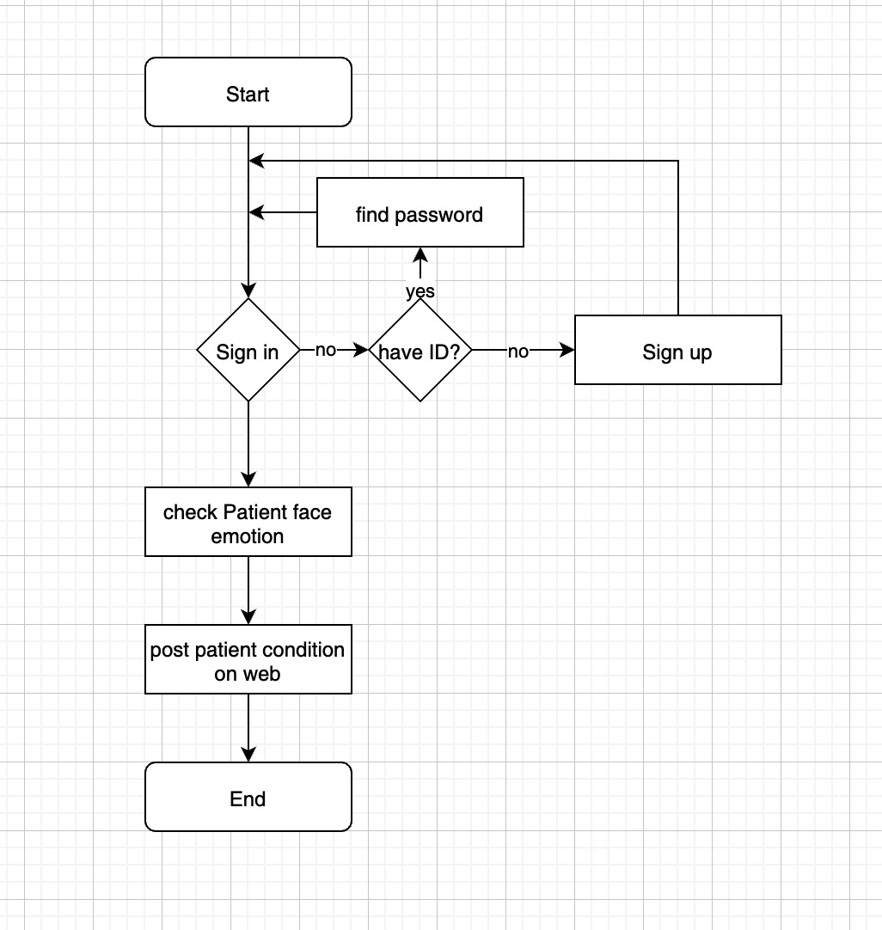

## 1.2 Functional requirements

After analyzing the system requirements, the initial planning of the system had the following functionalities:

1_worker should check patients condition via patients emotion

2_worker should record patients condtion on web

3_worker should check patients information on web

## 1.3 Non-functional requirements

The system must further possess the following nonfunctional requirements other than the functional requirements.

1_Performance: The function used by the user should present an output in less than 3 seconds.

2_Reliabilty The function must be able to recognize the subject’s face with a 99% probability.

3_Security: Only registered users should be able to access the system.

4_Safety:: This web should not use any meomory after it is closed.

5_Availabilty:This system must provide it’s service for 24hours a day, 365 days a year.

## 1.4 Additional Business Needs and Constraints

There are additional requirements other than those listed above.

1_python is selected as the development language and should operate in a project

2_The data that is implemented in the system must be precise.

## 1.5 User Requirement and Task Analysis

The user groups of this system are divided into two categories: worker, system administrators.  
Different users have different permissions and can perform different operations.

### 1.5.1 General user

General user have the most basic functionalities of check patients, there should be the following functions

1_View,browse,generate,delte report

2_View notice

3_View, add and delete patient information

4_The patient emotion check

5_Change own password

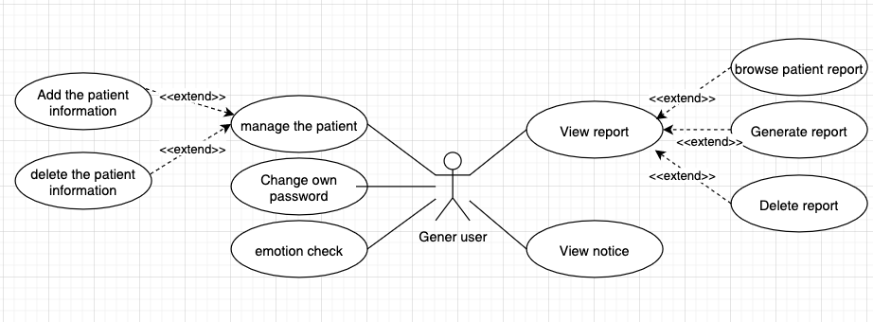

### 1.5.2 System administrators

System administrators have full access to systems within the limits of their business requirements. For system administrators there should have the following functions

1_View,add and delete notice

2_View, add and delete users.

3_View and add delete emotion data

3_Change own password

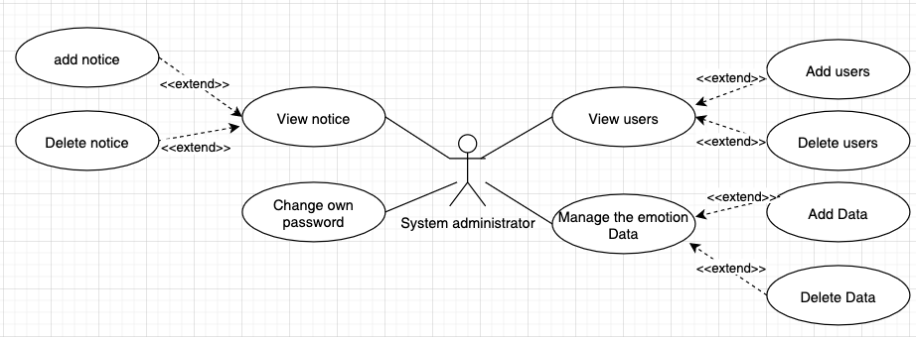

# 2. Database design

All data from web first stored in local SQLite database, then synchronized with server data using Synchronization module which facilitate by flask web to interact with server database.

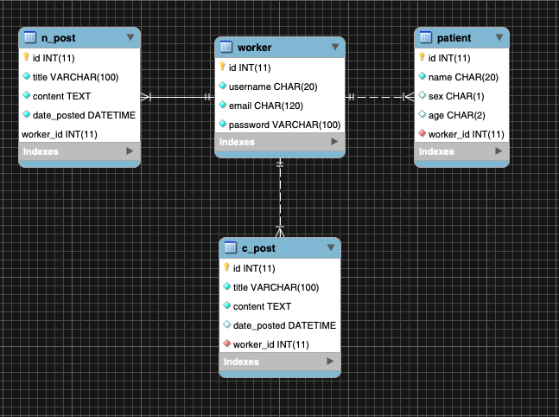

## 2.1 Worker

|  |  |  |
| --- | --- | --- |
| Column name | Type | Description |
| Id | INT(11) | Worker ID |
| Username | CHAR(20) | Worker Usename |
| Email | CHAR(120) | Worker email |
| Password | VARCHAR(100) | Worker password |

## 2.2 N_post

|  |  |  |
| --- | --- | --- |
| Column name | Type | Description |
| Id | INT(11) | Post number |
| Title | VARCHAR(100) | Notice title |
| Content | TEXT | Notice content |
| Data_poshed | DATETIME | Post date |
| Worker_id | INT(11) | Worker id |

## 2.3 C_post

|  |  |  |
| --- | --- | --- |
| Column name | Type | Description |
| Id | INT(11) | Post number |
| Title | VARCHAR(100) | Patient information title |
| Content | TEXT | Patient information content |
| Data_posted | DATETIME | Post data |
| Worker_id | INT(11) | Worker id |

## 2.4 Patient

|  |  |  |
| --- | --- | --- |
| Column name | Type | Description |
| Id | INT(11) | Patient number |
| Name | CHAR(20) | Patient name |
| Sex | CHAR(2) | Patient sex |
| Age | CHAR(1) | Patient age |
| Worker id | INT(11) | Worker id |

# 3. Development Tools

This section presents all technologies which are used during the development of the project.

## 

## 3.1 Software specifications

### 3.1.1 Development information

Base Language : Python

IDE: Pycharm, Spyder

Training Tool: Google Colab

### 3.1.2 Computer Vision Part

* Tensorflow --1.15.0
* Keras --2.3.1
* OpenCV --4.2.0.32
* Numpy --1.18.2

### 3.1.3 Web part

* Flask --1.1.1
* Flask-SQLAlcheamy --2.4.3
* Flask-Bcrypt --0.7.1
* Flask-Login --0.5.0
* Flask-LoginManager --1.1.6
* Flask-Migrate --2.5.3
* Flask-wtf --0.14.3
* pymysql --0.9.3
* email-validator --1.1.1

4. Our Project Schedule

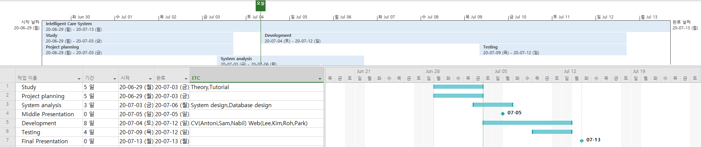

Computer Vision part: Antonio, Sam, Nabil, Park

Web Part: Lee, Kim, Roh, Park

# 5. Computer Vision Part

5.1 Dataset

We trained and tested our models on the data set from the Kaggle Facial Expression Recognition Challenge, which comprises 48-by-48-pixel grayscale images of human faces, each labeled with one of 5 emotion categories:**anger, happiness, sadness, surprise, and neutral**.

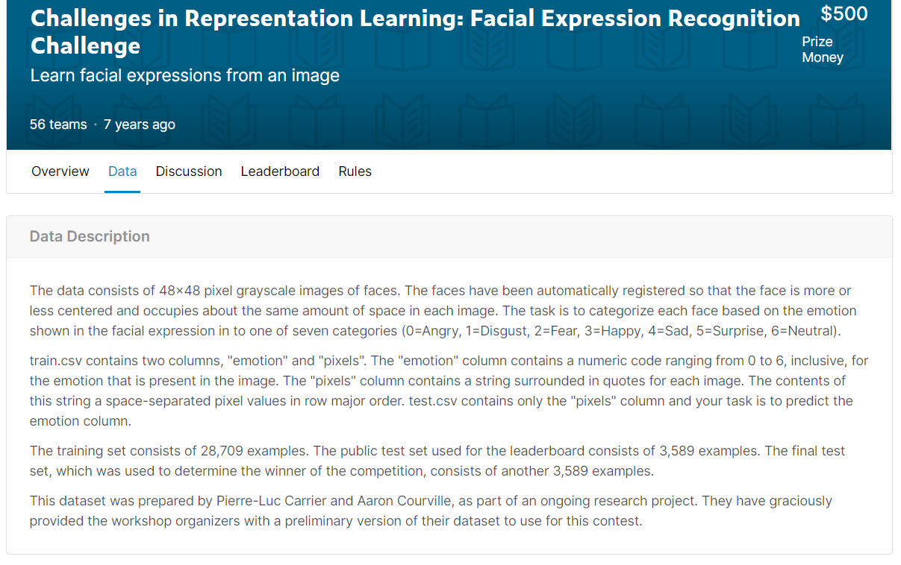

<https://www.kaggle.com/c/challenges-in-representation-learning-facial-expression-recognition-challenge/data>

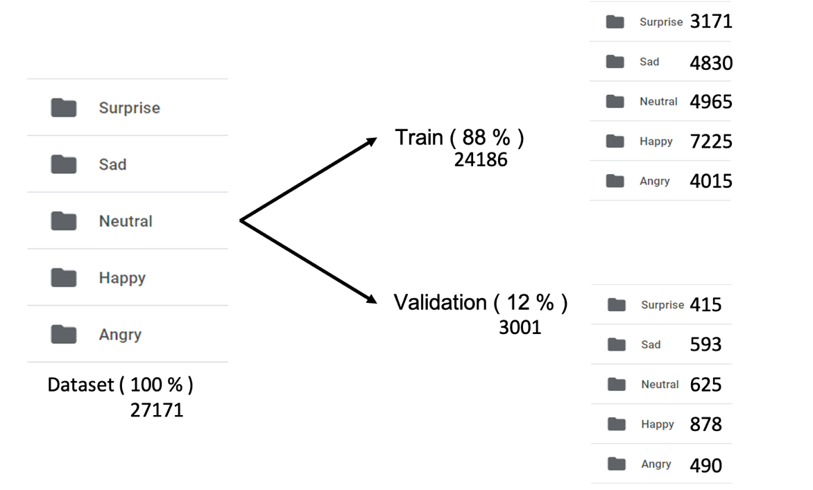

In the Machine Learning process, They required training and validation. So the dataset had to be separated by like this.

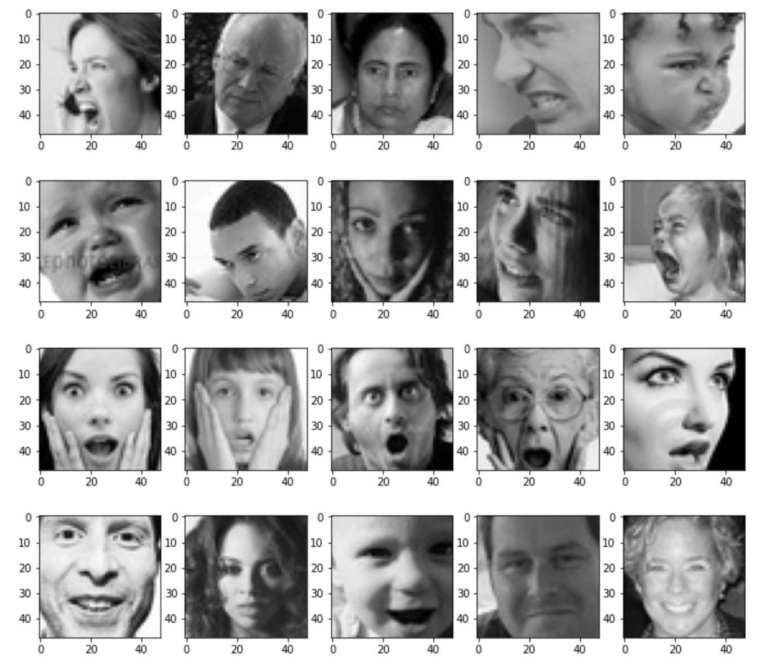

Image files are randomly shuffled before training to improve accuracy.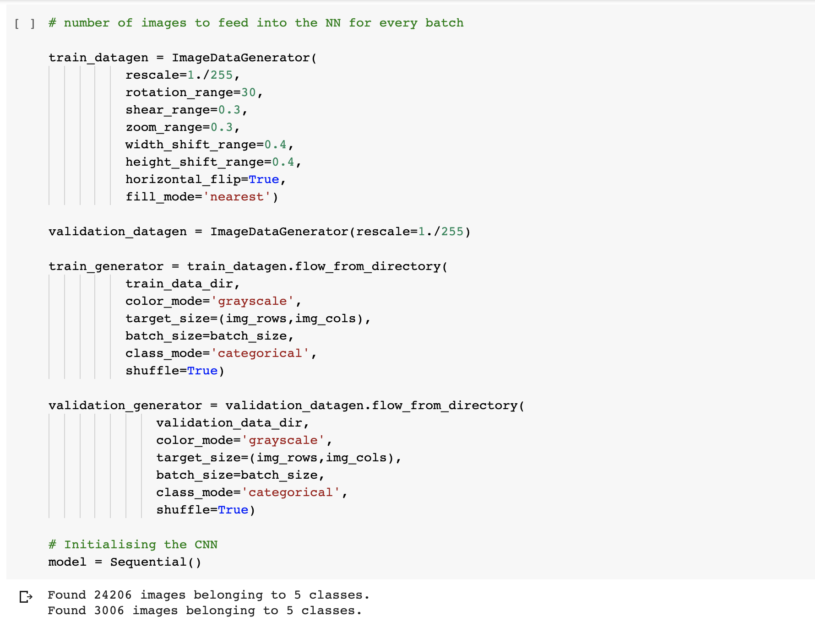

Deep learning models are trained by being fed with batches of data. Keras has a very useful class to automatically feed data from a directory: ImageDataGenerator.

It can also perform data augmentation while getting the images (randomly rotating the image, zooming, etc.). This method is often used as a way to artificially get more data when the dataset has a small size.

The function flow_from_directory() specifies how the generator should import the images (path, image size, colors, etc.).

5.2 Set CNN layer

We chose to use a Convolutional Neural Network in order to tackle this face recognition problem. Indeed this type of Neural Network (NN) is good for extracting the features of images and is widely used for image analysis subjects like image classification.

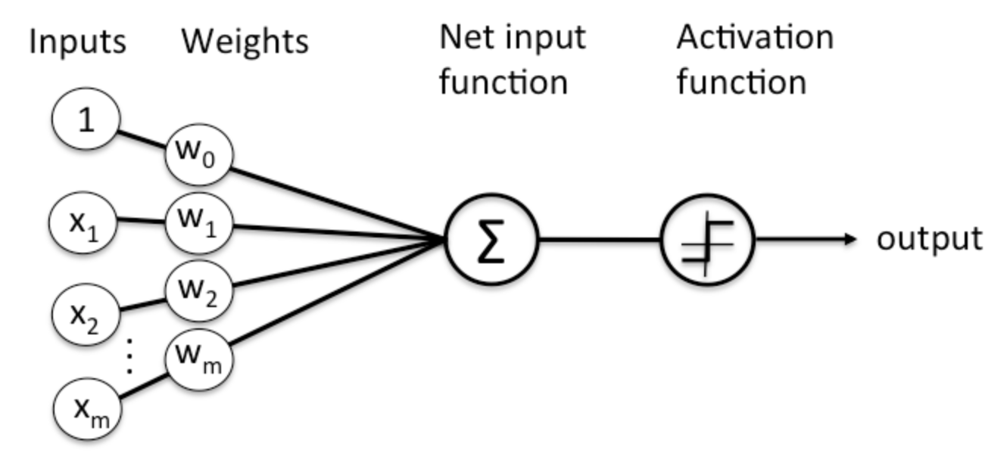

A Neural Network is a learning framework that consists in multiple layers of artificial neurons (nodes). Each node gets weighted input data, passes it into an activation function and outputs the result of the function.

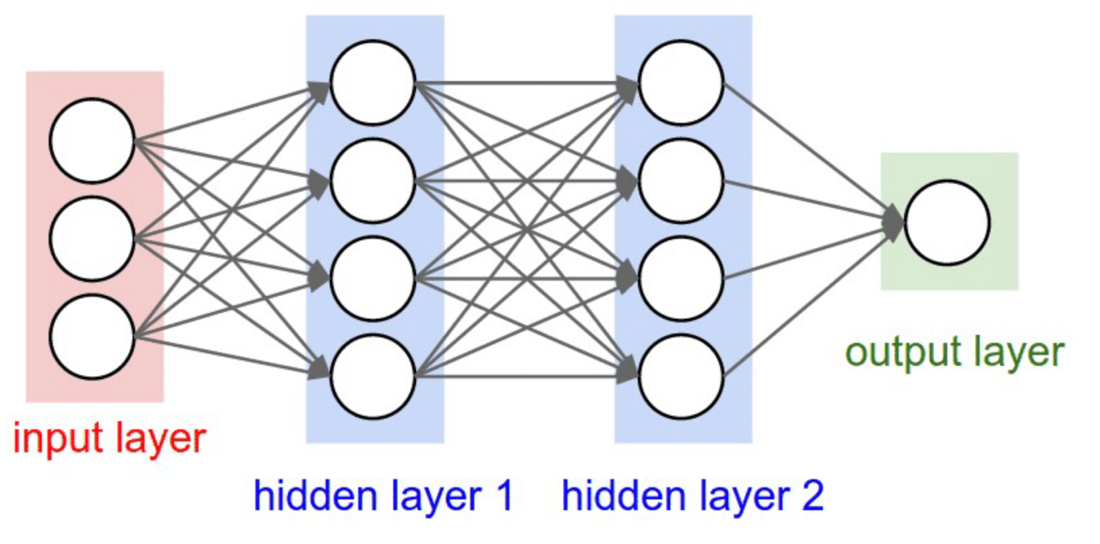

* An input layer that will get the data. The size of the input layer depends on the size of the input data.
* Some hidden layers that will allow the NN to learn complex interactions within the data. A Neural Network with a lot of hidden layers is called a Deep Neural Network.
* An output layer that will give the final result, for instance a class prediction. The size of this layer depends on the type of output we want to produce (e.g. how many classes do we want to predict?)

Classic NNs are usually composed of several fully connected layers. This means that every neuron of one layer is connected to every neurons of the next layer.

Convolutional Neural Networks also have Convolutional layers that apply sliding functions to group of pixels that are next to each other. Therefore those structures have a better understanding of patterns that we can observe in images.

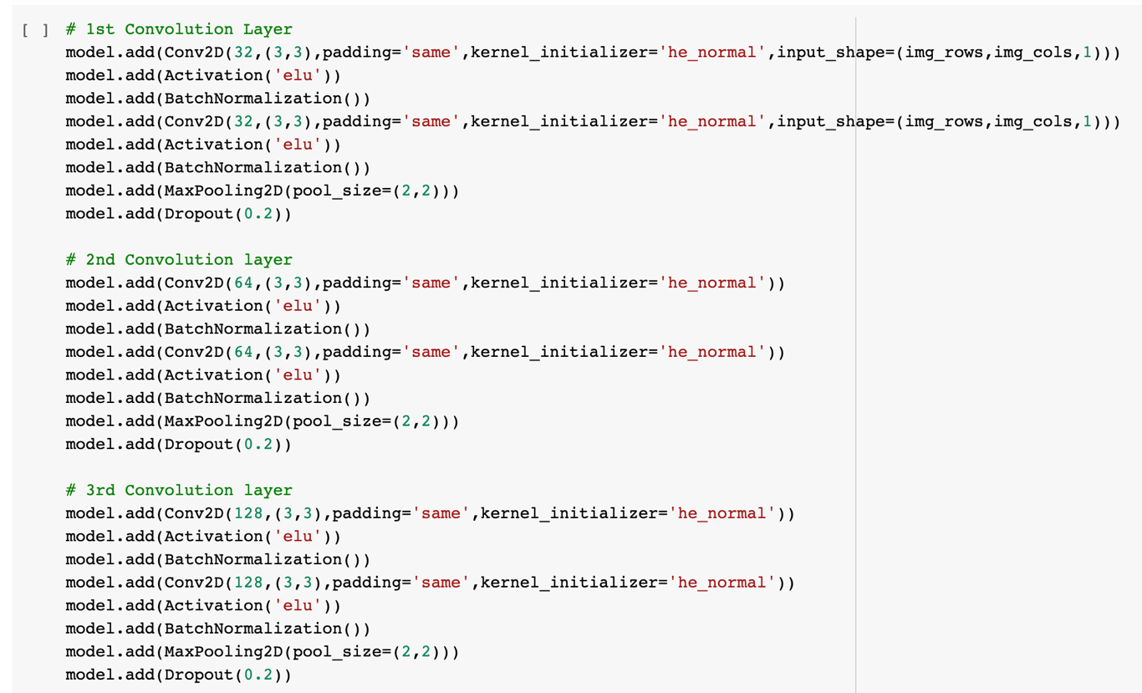

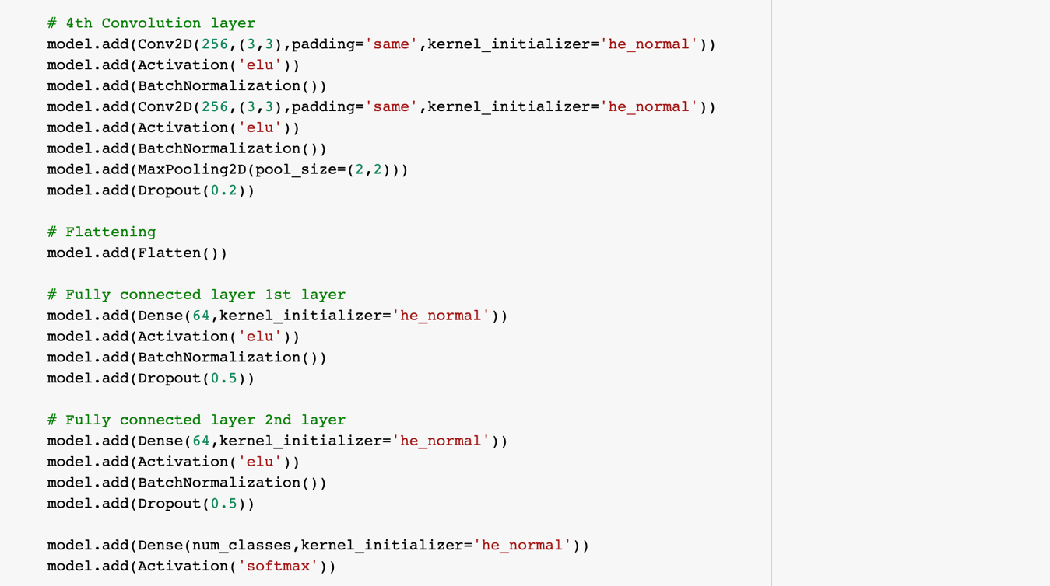

We define our CNN with the following global architecture:

* 4 convolutional layers
* 2 fully connected layers

The convolutional layers will extract relevant features from the images and the fully connected layers will focus on using these features to classify well our images.

A convolution operator: extracts features from the input image using sliding matrices to preserve the spatial relations between the pixels. The following image summarizes how it works:

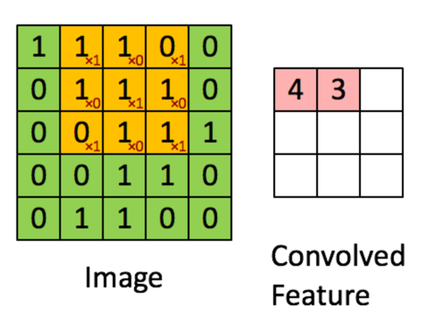 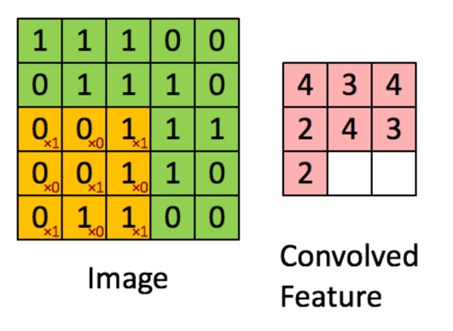

The green matrix corresponds to the raw image values. The orange sliding matrix is called a 'filter' or 'kernel'. This filter slides over the image by one pixel at each step (stride). During each step, we multiply the filter with the corresponding elements of the base matrix. There are different types of filters and each one will be able to retrieve different image features.

We apply the eLU function exponentional linear unit in our model. Other functions like hyperbolic tangent or sigmoid could also be used, but eLU has been found to perform better in most situations. Pooling is used to reduce the dimensionality of each features while retaining the most important information. Like for the convolutional step, we apply a sliding function on our data. Different functions can be applied: max, sum, mean... The max function usually performs better.

We also use some common techniques for each layer:

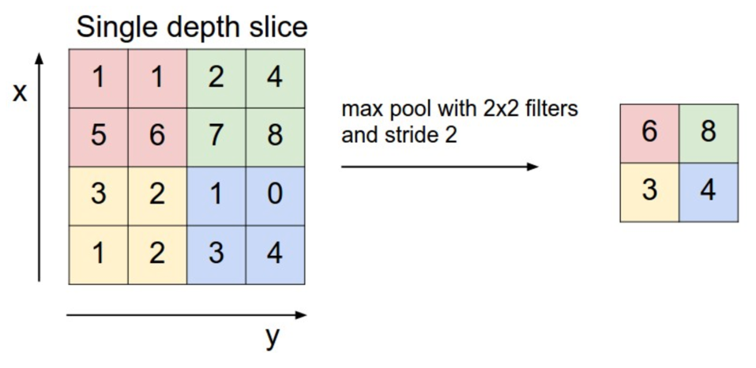

* Batch normalization: improves the performance and stability of NNs by providing inputs with zero mean and unit variance.
* Dropout: reduces overfitting by randomly not updating the weights of some nodes. This helps prevent the NN from relying on one node in the layer too much.

We chose softmax as our last activation function as it is commonly used for multi-label classification.

5.3 Train the model

CNN is defined, we can compile it with a few more parameters. We chose the Adam optimizer as it is one of the most computationally effective. We chose the categorical cross-entropy as our loss function as it is quite relevant for classification tasks. Our metric will be the accuracy, which is also quite informative for classification tasks on balanced datasets.

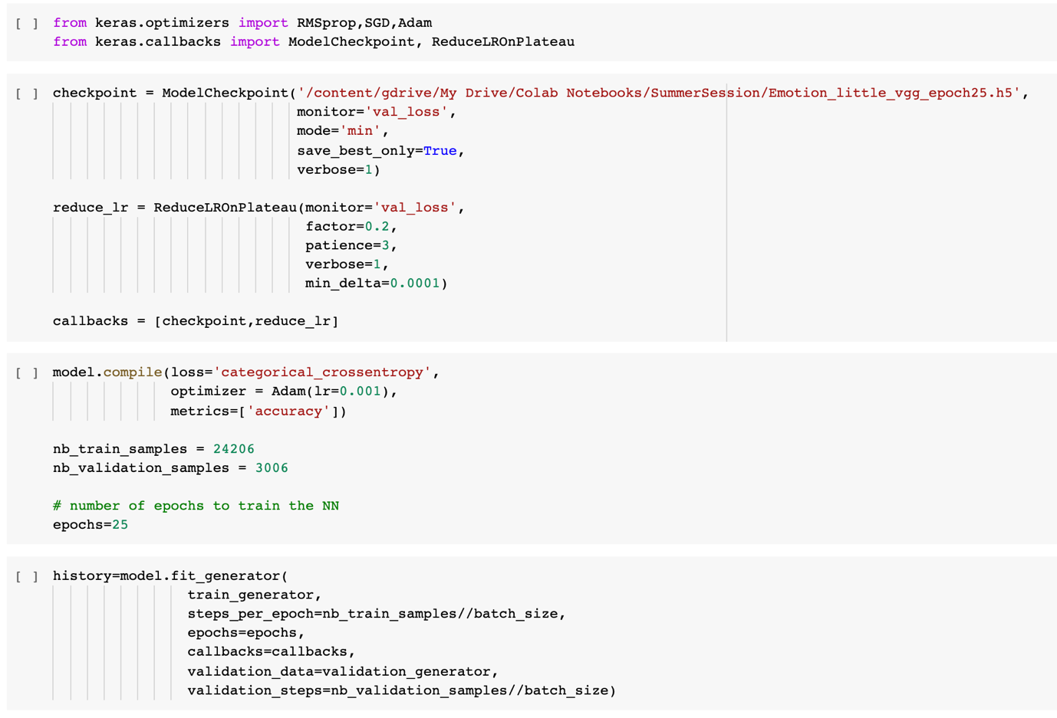

It took about 6 hours to train through 25 times. There was not much time to train because there are fewer image files to train.

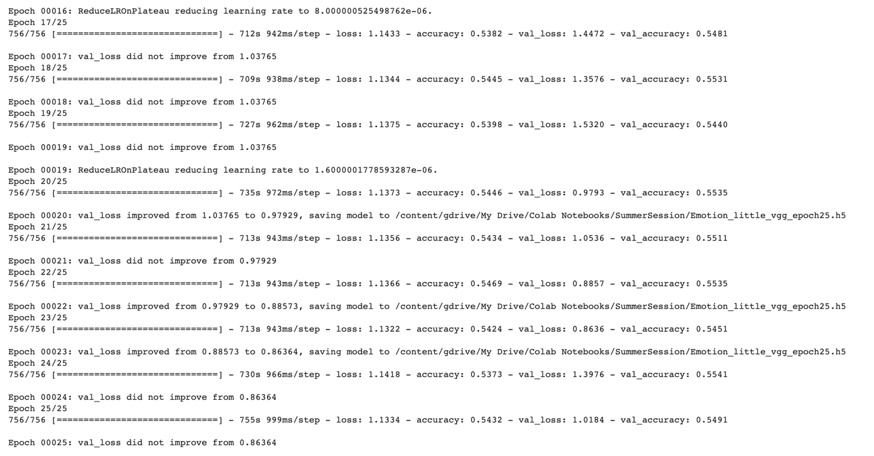

5.4 Training result

The highest Accuracy is almost 55% and loss value is 1.1334 were obtained through 25 times training.

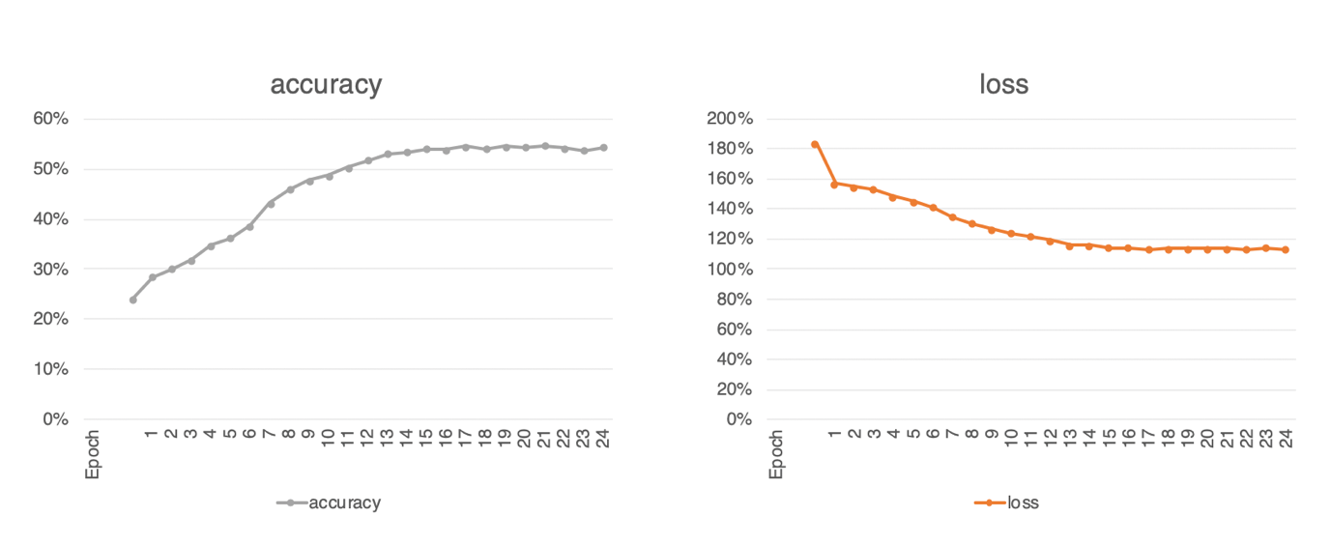

Save this operation as a .h5 file, we can test it.

5.5 Test the Model

Finally, we use the Test module for test our trained model, They showed the percentage of their prediction when Park smiled, This system showed about 55.7% he was Happy.

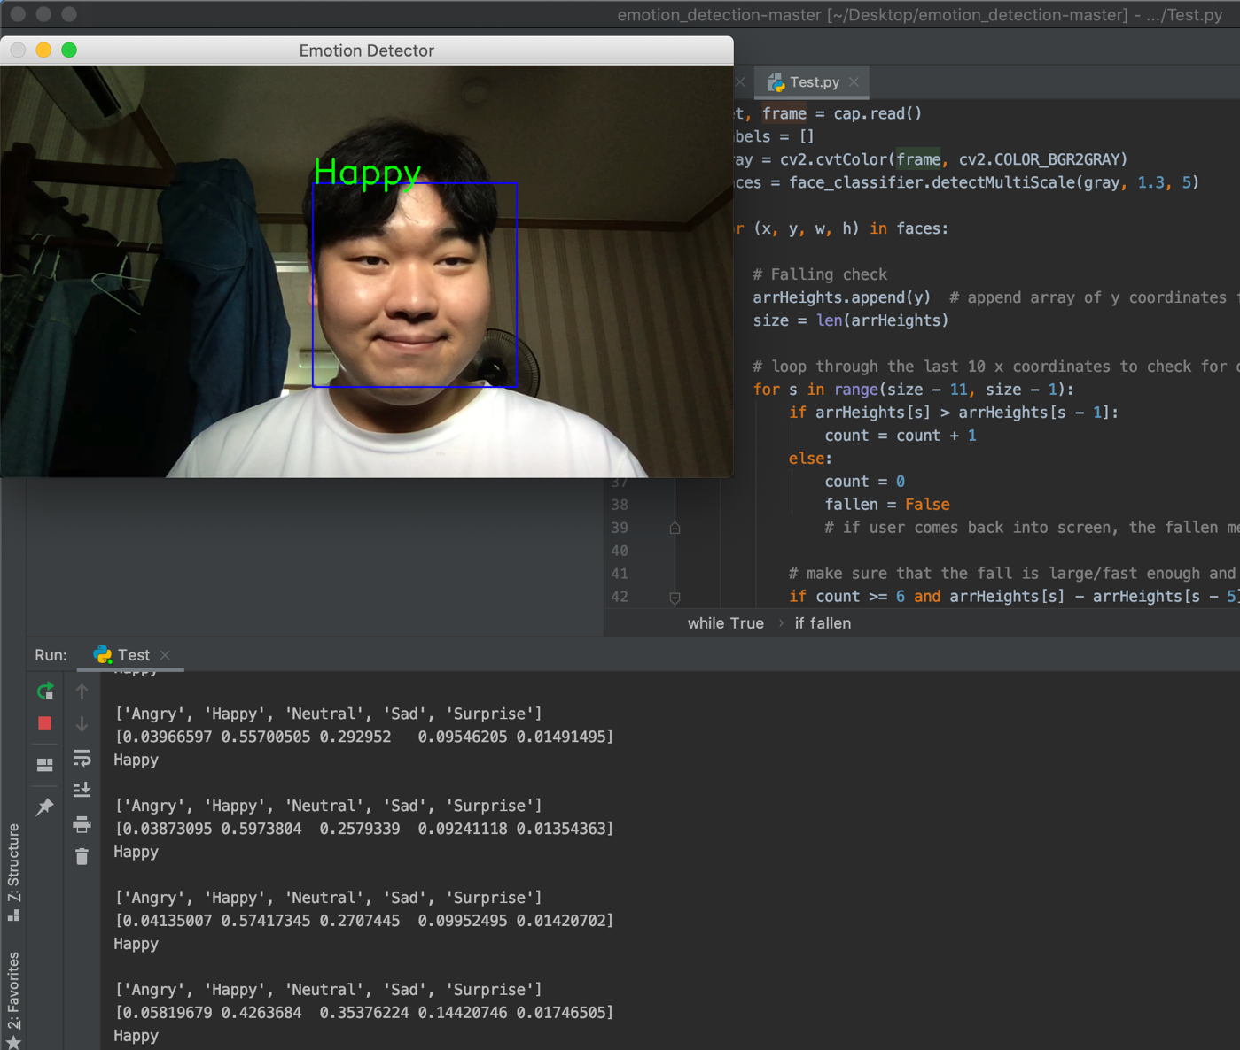

On the other hand, when Park looks angry. it showed about 59.04% he was Angry.

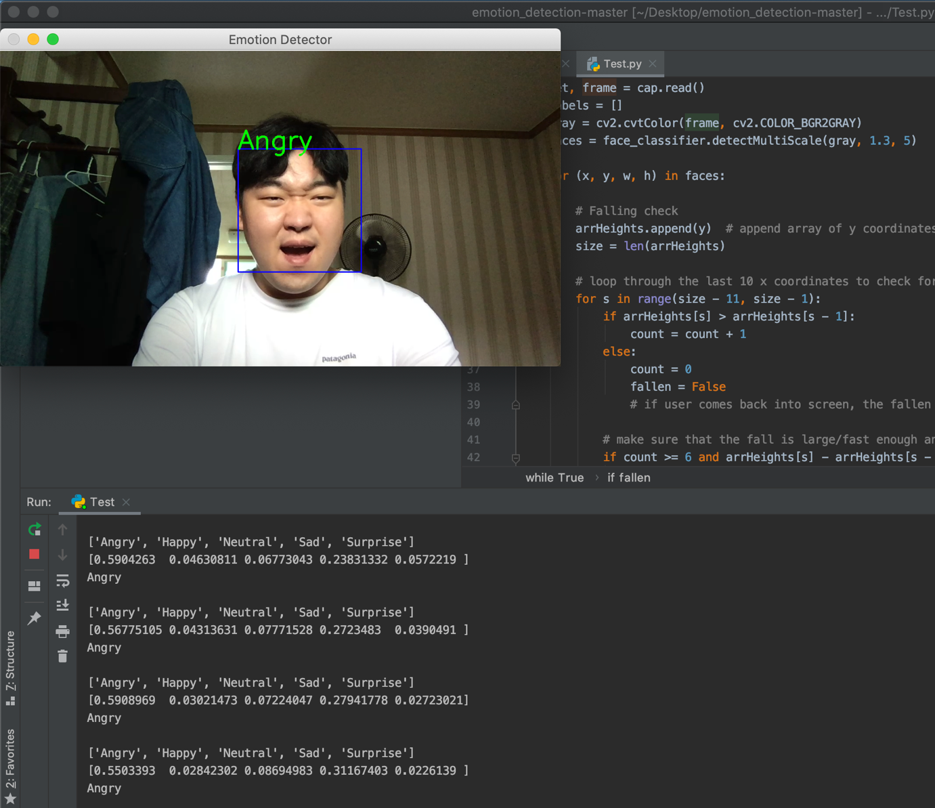

5.6 FALLEN function

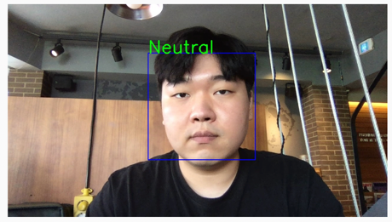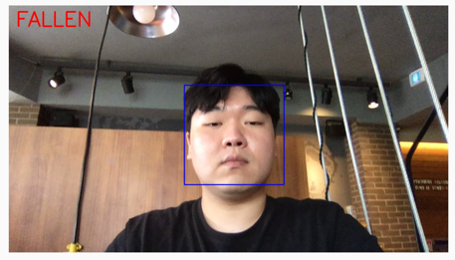

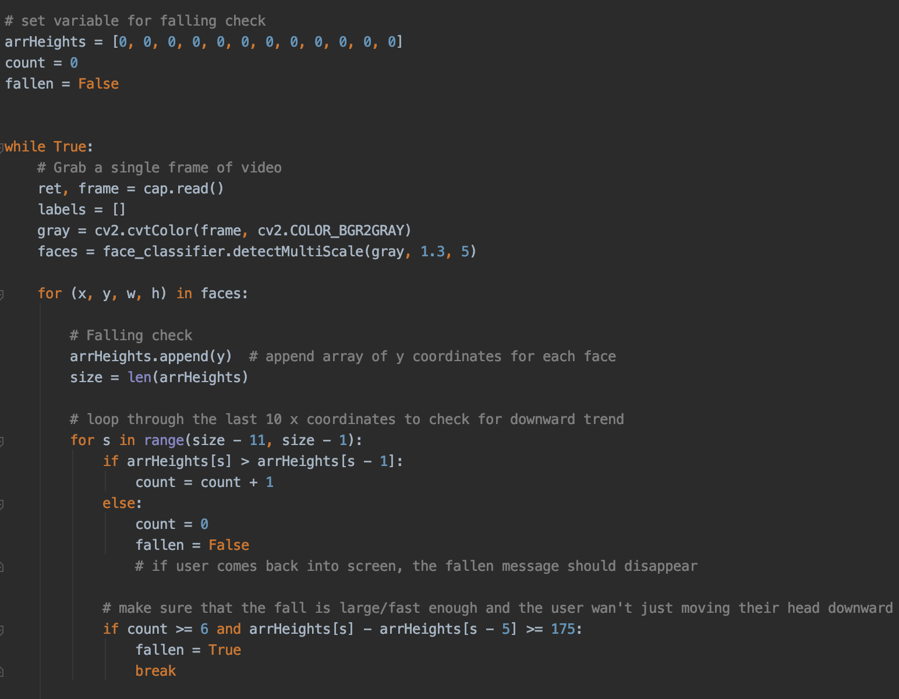

During the laptop camera recognized the patient’s face, they check their face position. Suddenly patient fallen, the system showed FALLEN message into the screen. After user came back into screen, the massage should disappear.

# 6. Web System Part

In this project, we used the Python Flask web framework for implement the Web system.

And using the Flask-SQLAlcheamy connect to the Database.

<Initial screen>

When worker open the browser for start their work, The system can not show the screen before they login.

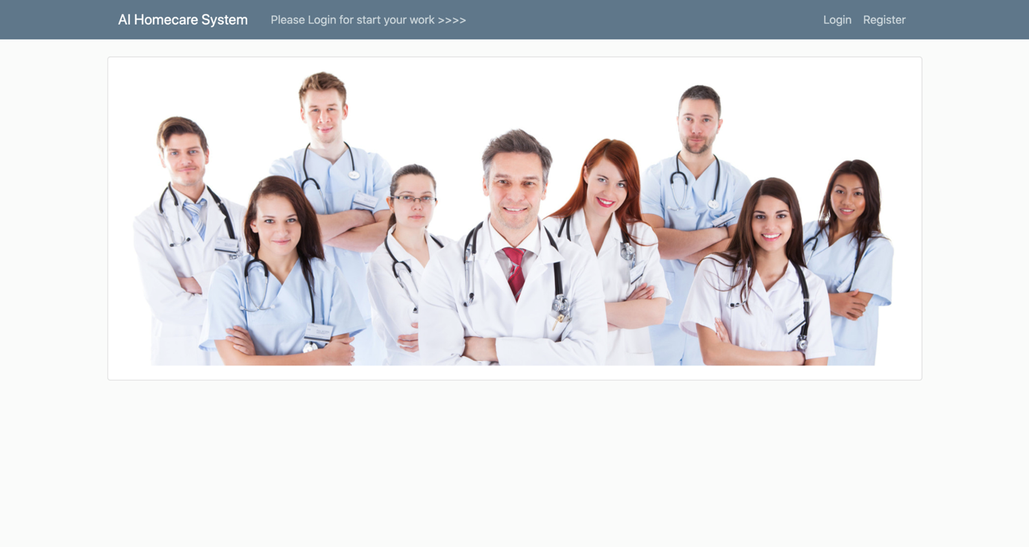

<Login screen>

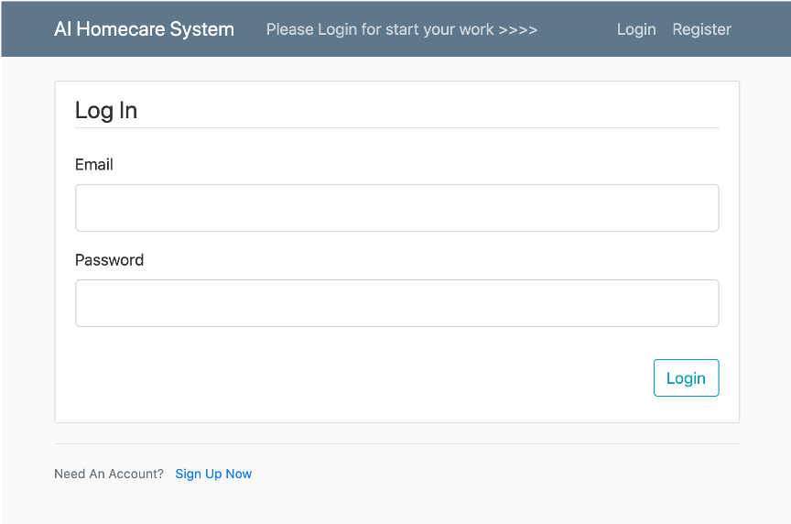

<Signup screen>

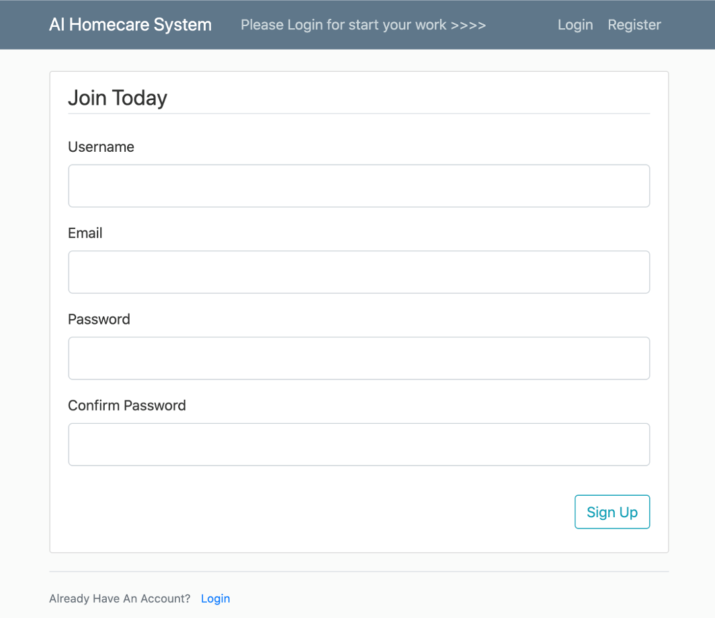

When they sign up the system, their password will be encrypt.

<worker Table>

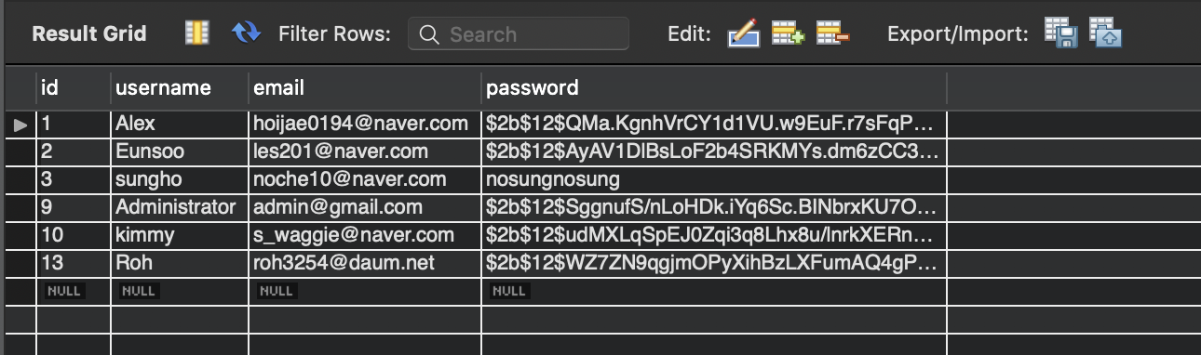

<Main screen>

When worker login the system, first of all they can check the report from the other worker and notice from the System.

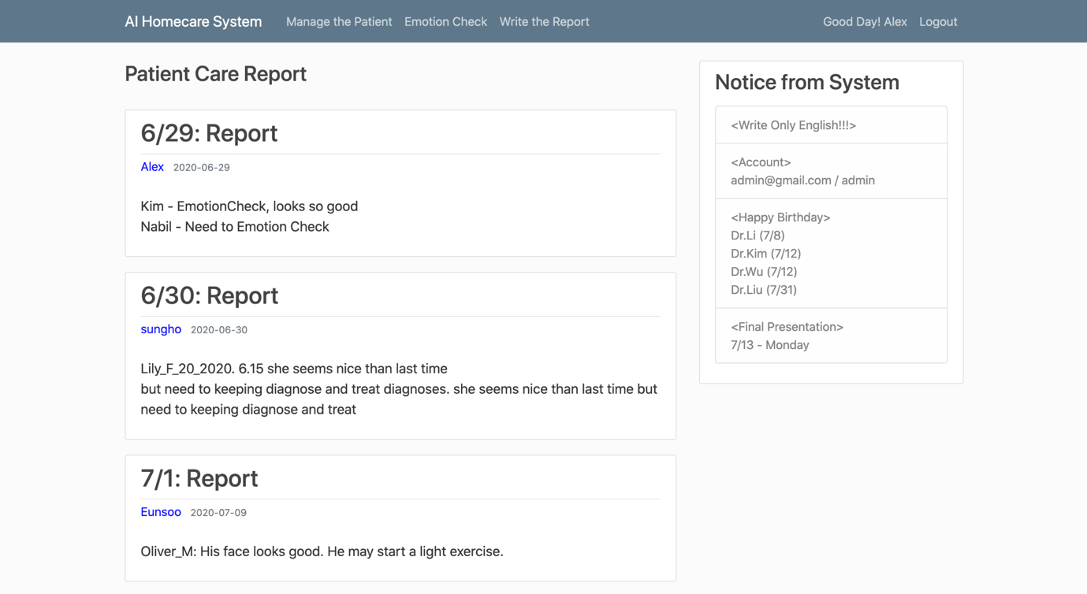

<c_post Table>

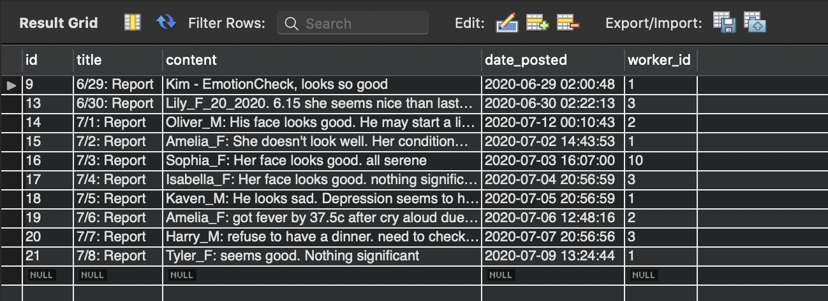

<Manage the Patient screen>

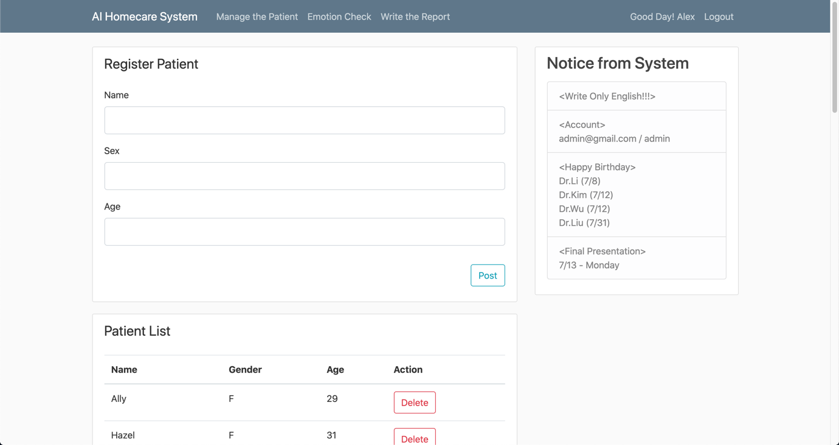

Worker can register the new patient, and check the patient list. When the patient leave the system, worker can remove from the list.

<patient Table>

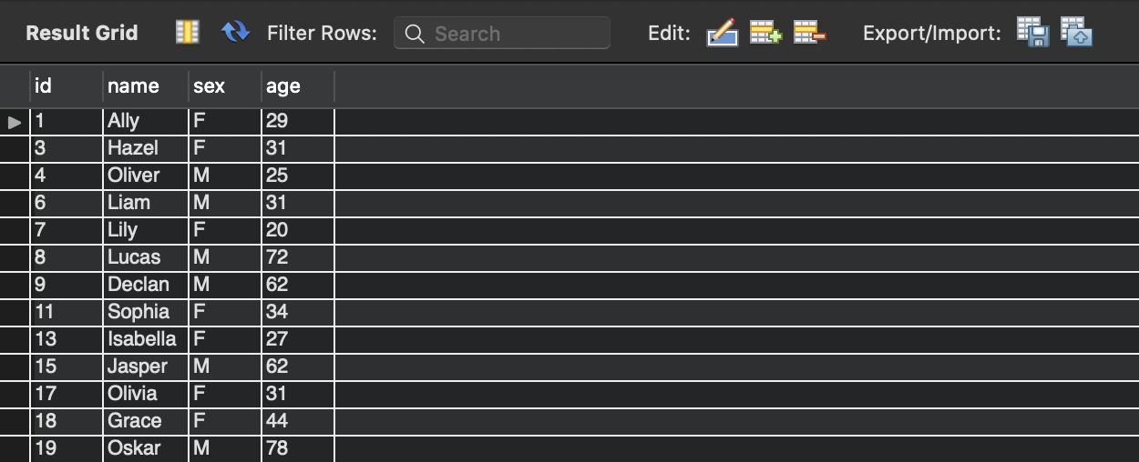

<Emotion Check screen>

The Patient diagnose this page their face emotion. The system can catch their face emotion to 5 categories [ Neutral, Angry, Happy, Sad, Surprised ]. and catch the FALLEN motion check.

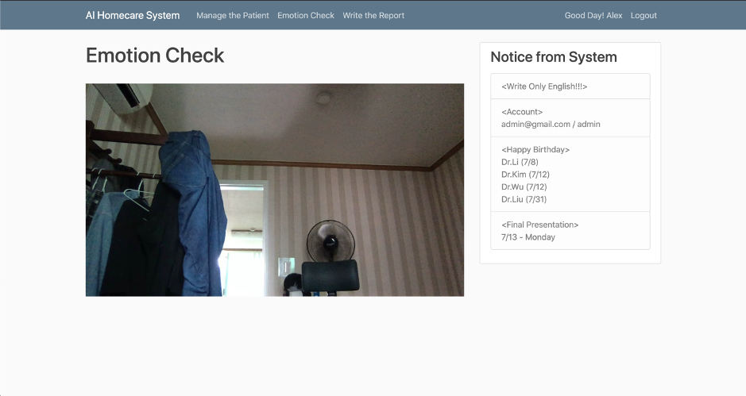

<Write the Report>

When the worker finished the patient diagnose, he can write the report on this page. Then, other workers also checked in the main page.

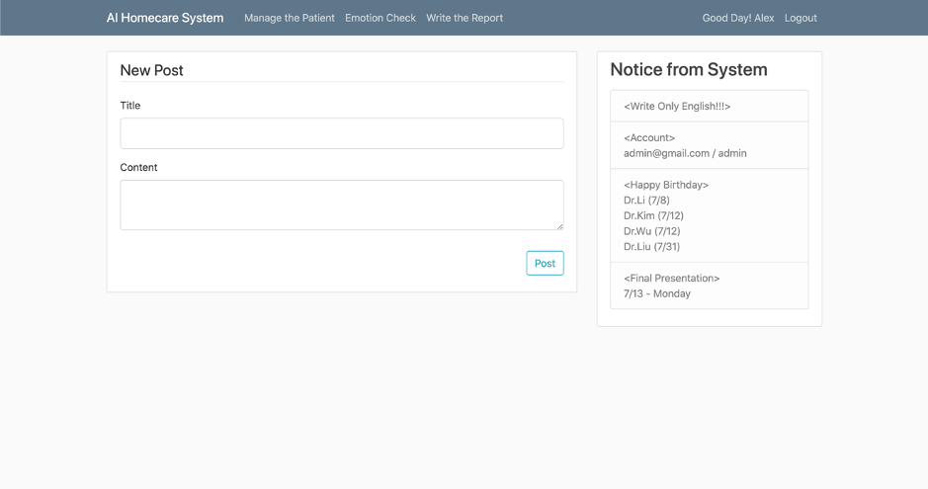

<Administrator Main>

Administrator can see the Notice list in the Admin’s main page. This notice list also showed in the worker’s page only notice contents.

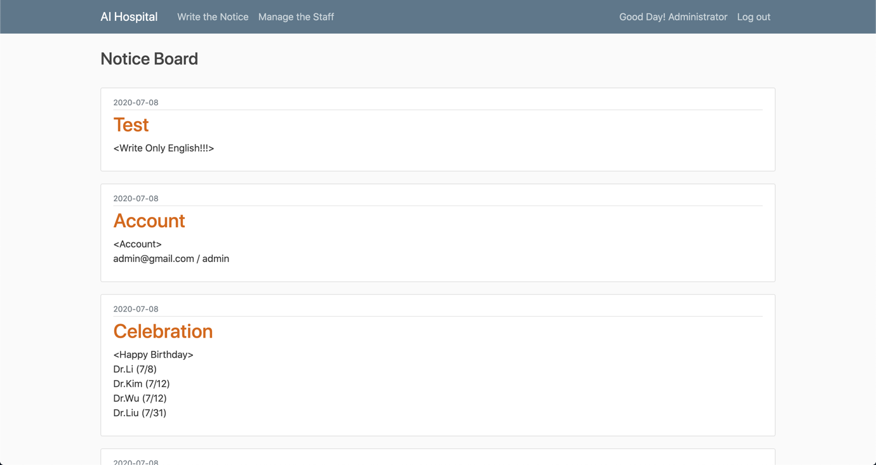

<n_post Table>

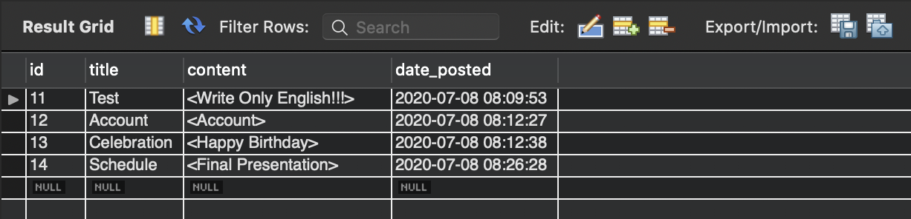

<Write the Notice>

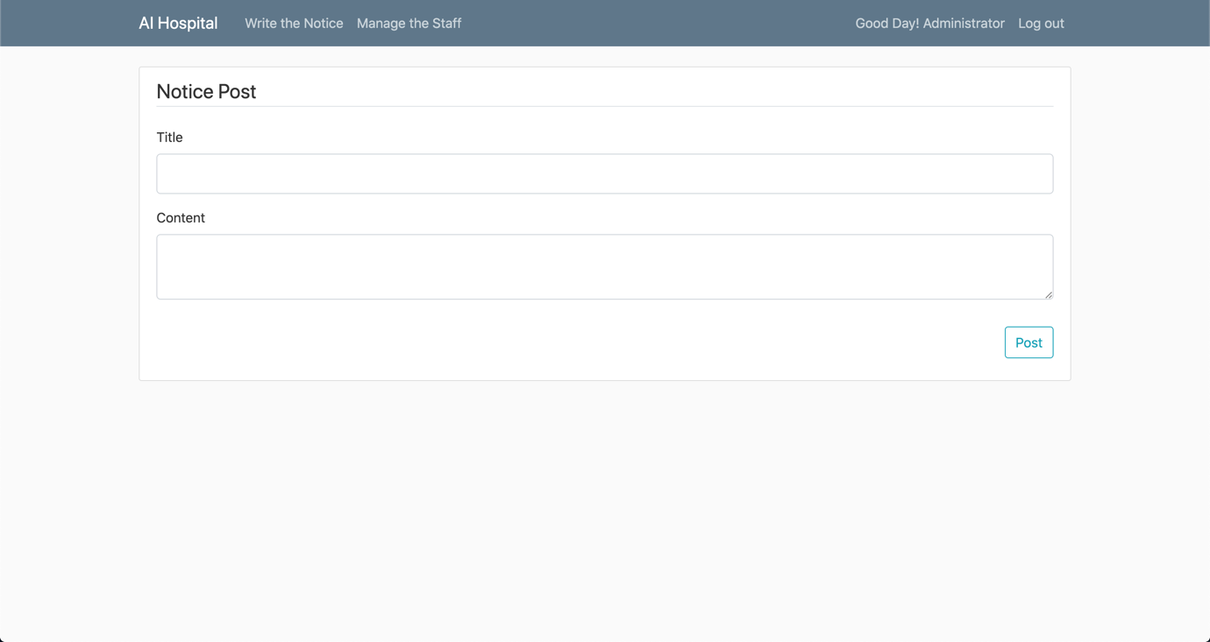

<Manage the Staff>

In this page, Administrator can manage the Worker information. when they leave the company he can remove from the server.

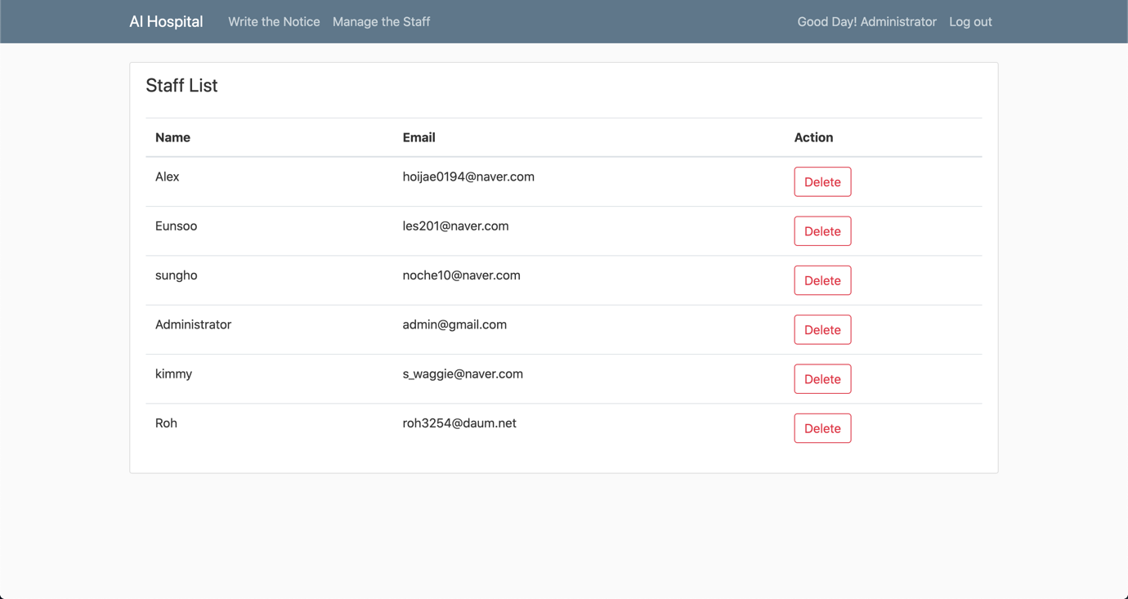

7. Conclusion

Before starting the project, we shared our roles and noticed the progress of each day to keep track of the progress of the project. Each teammate has been steadily uploaded to Git Hub to proceed for 2 weeks.

Image processing model, such as Face recognition with Sentimental Analysis and Motion Capture are important research area that are frequently used in our life. In the study of Image processing, it is very important to create a dataset necessary for training as well as algorithm development. we had to work on the project for a short period of two weeks, so we used the open source dataset from Kaggle. As an algorithm for processing image processing, we used the most commonly used CNN technique. Training data was extracted using 4 convolutional layers and 2 fully-connected layers. It was trained about 25 times for 6 hours, a trained file with 54% accuracy was produced.

The main users of the web system which implemented Python Flask web framework are staff and administrator. The login function, patient list management function, emotion check function using the trained file and write, modify, delete of diagnostic reports are implemented on the staff page. On the admin page, notices can be written, modified, deleted, and staff information can be deleted.

In the future work, we need to make our own dataset from the web searching for training our project. and try to find the ways to improve accuracy using various algorithms.